How to Install your 10” Non-Integrated Display to a RJ-45 port Butler

**\*Please note that we do not have these parts hooked up to a machine so you can see them better. We recommend you install the Butler and Display bracket to your machine before hooking up all the cables\***

This is what you will require in order to connect your display.

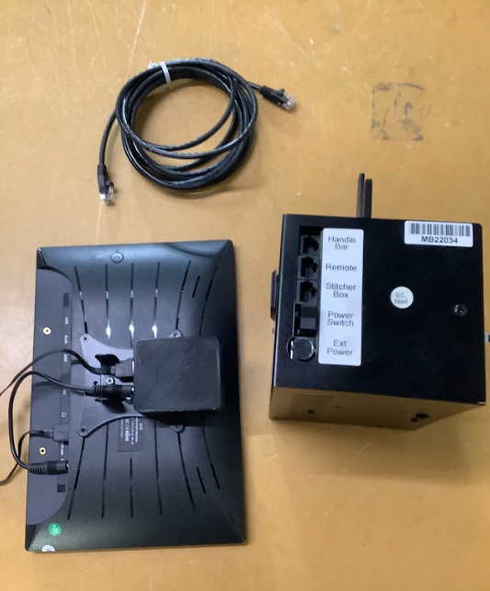

Ethernet Cable

Classic Butler

EPC Display

You are going to want to connect your display bracket on your display to your display bases on your display bracket that is connected to your machine. The picture below shows the display bases in Blue Rectangles.

\***Some display brackets and bases are white, some are black**\*

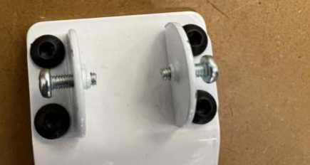

Take out both of the screws

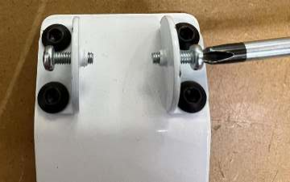

Align the holes in the display clamp with the holes in the display bases. *You may need more than one person for this step*.

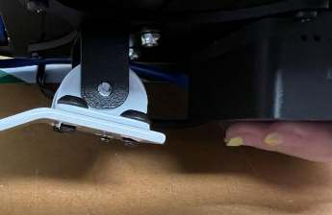

**\*You will want to make sure the screws are tight enough to hold the display. Then adjust the display to the angle you would like and finish tightening the screws.\***

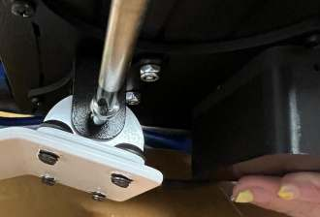

You are now going to connect the Butler and the Ethernet cable.

Take one end of the Ethernet Cable and plug it into the Remote port on the Butler.

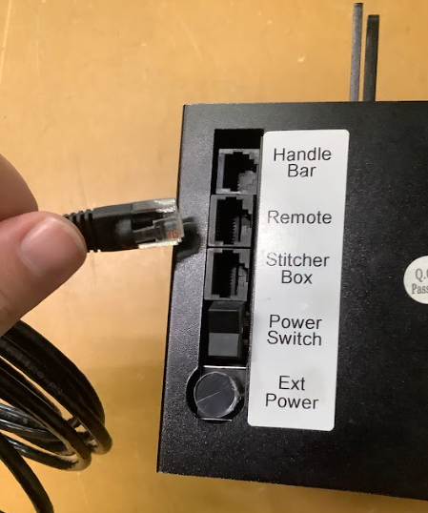

Ethernet Cable End

Remote Port

Run the other end of the Ethernet cable along the side of your machine and plug it into the RJ-45 port on the Translator (the small black box connected to the display).

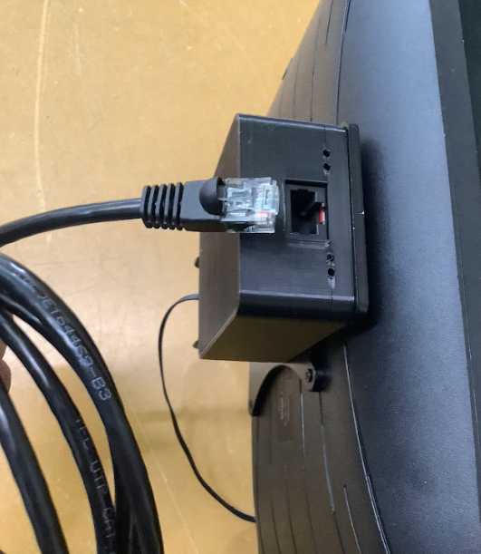

RJ-45 Port on Translator

Ethernet Cable End

**\*Two cords will come out of the Translator and plug into the Display, this is where they connect. *They should be connected already, but this is where they belong if they aren’t*\***

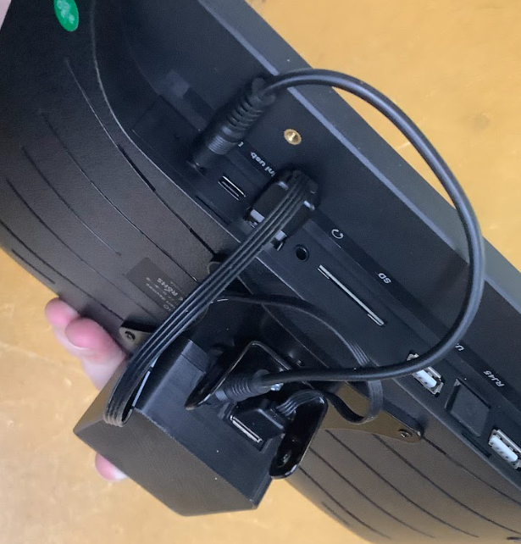

You are all ready to turn on your system! Enjoy!