How to Install your 8”, 10” and 12” Integrated Display

***\* Please note that we do not have these parts hooked up to a machine so you can see them better. We recommend you install the Butler and display to your machine before hooking up all the cables\****

This is what you will receive in order to install your display.

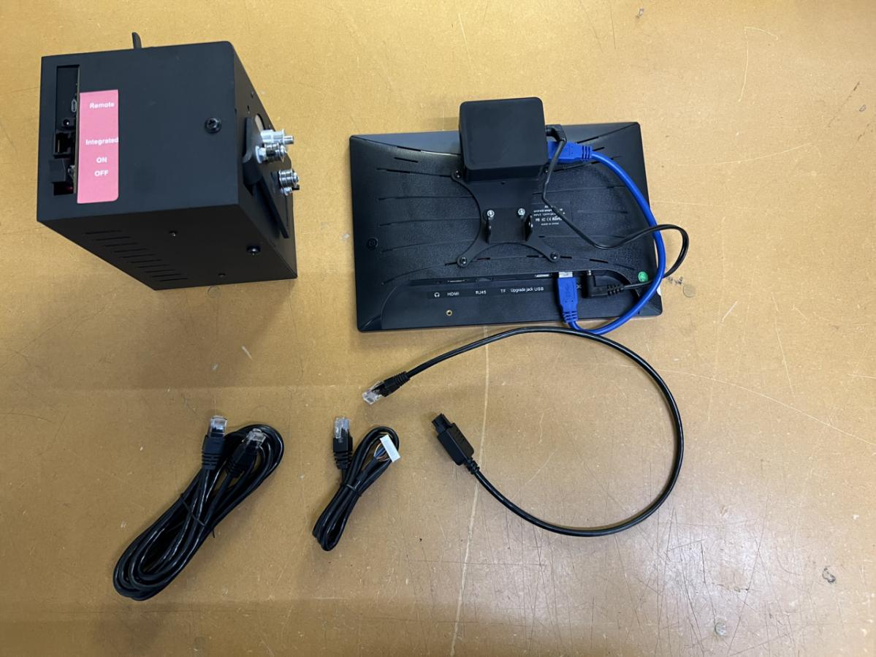

Translator

Butler

Display

Internal Remote Cable

Ethernet Cable

You are going to want to connect your display clamp to your display bases on your display bracket. The picture below shows the display bases are in the blue rectangles.

***\*Some display brackets and bases are white, some are black\****

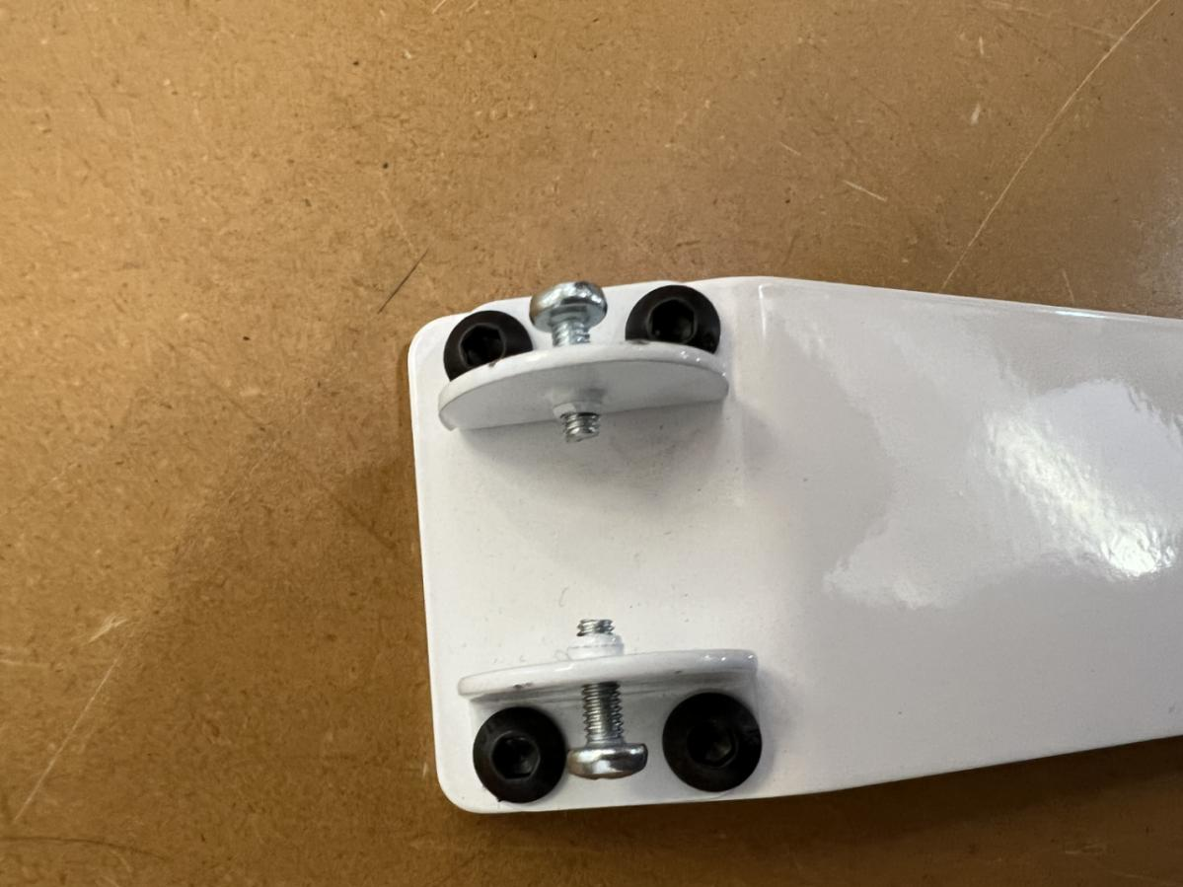

Take out both of the screws

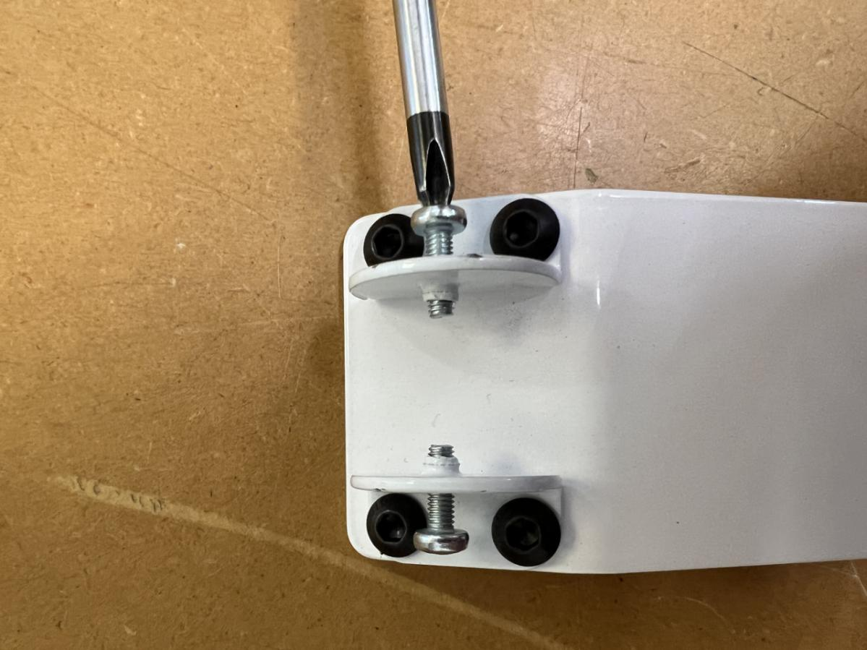

Align the holes in the display clamp with the holes in the display bases. You may need more than one person for this step.

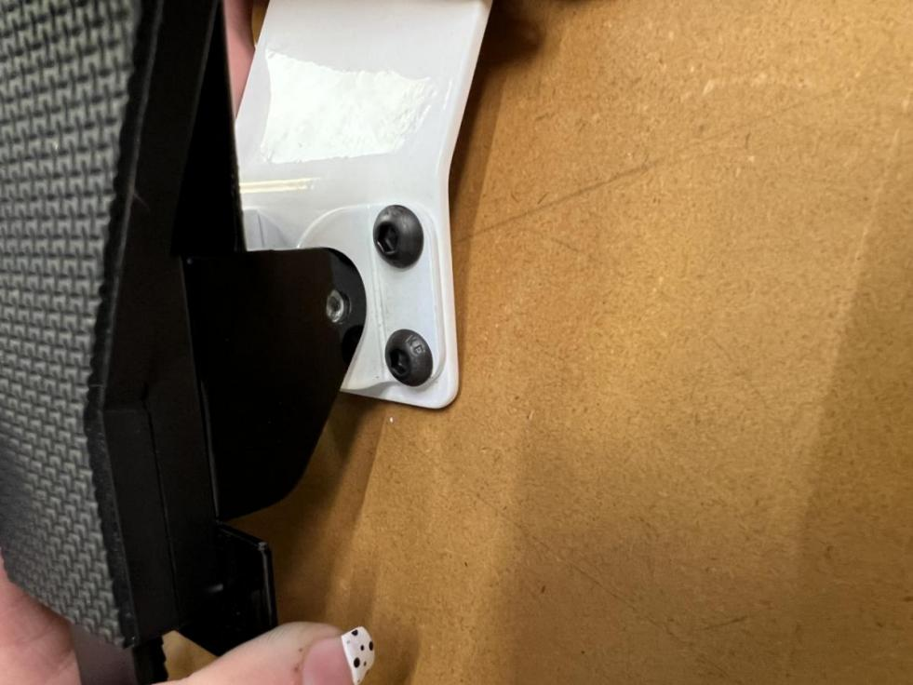

Screw the screws back into the bracket.

*You will want to make sure the screws are tight enough to hold the display. Then adjust the display to the angle you like and then finish tightening the screws.*

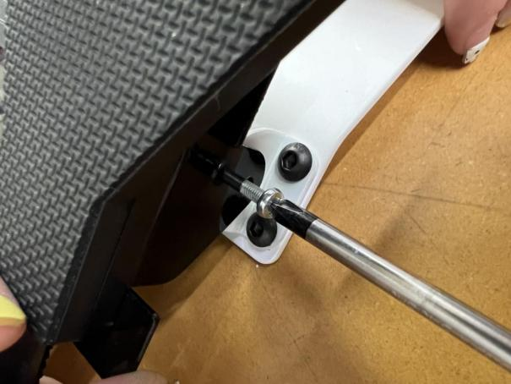

We are now going to connect the Butler and the Ethernet Cable.

Take one end of the Ethernet cable and plug it into the integrated port on the Butler.

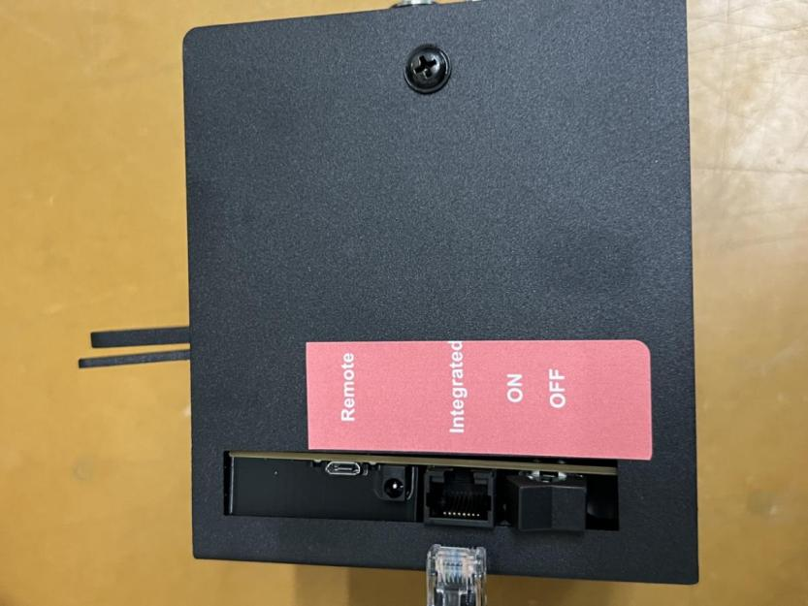 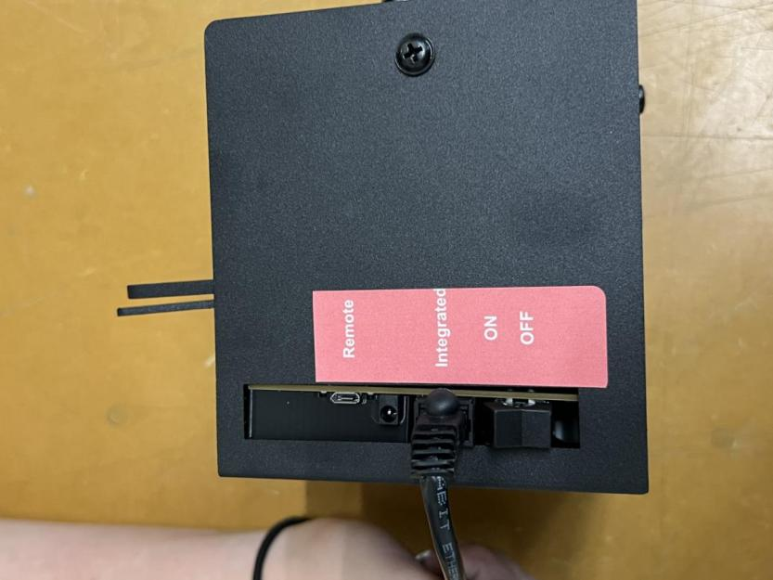

Run the other end of the Ethernet cable along side your machine and then plug it into the robotics port on the white or black box of your long arm machine. (If you are looking at the front of your machine, the white or black box is on the right side at the back of your machine, it is where the power cable plugs in.)

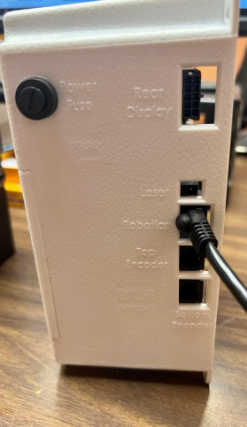

Depending on how your machine was made there are two different ways to hook up the next part of the display.

The first way is if your machine has a side port under the rocker arm cover. The rocker arm cover is the rectangular cover on the front left side of the machine (if you are facing the front of the machine) just in front the thread stand. See picture on the next page.

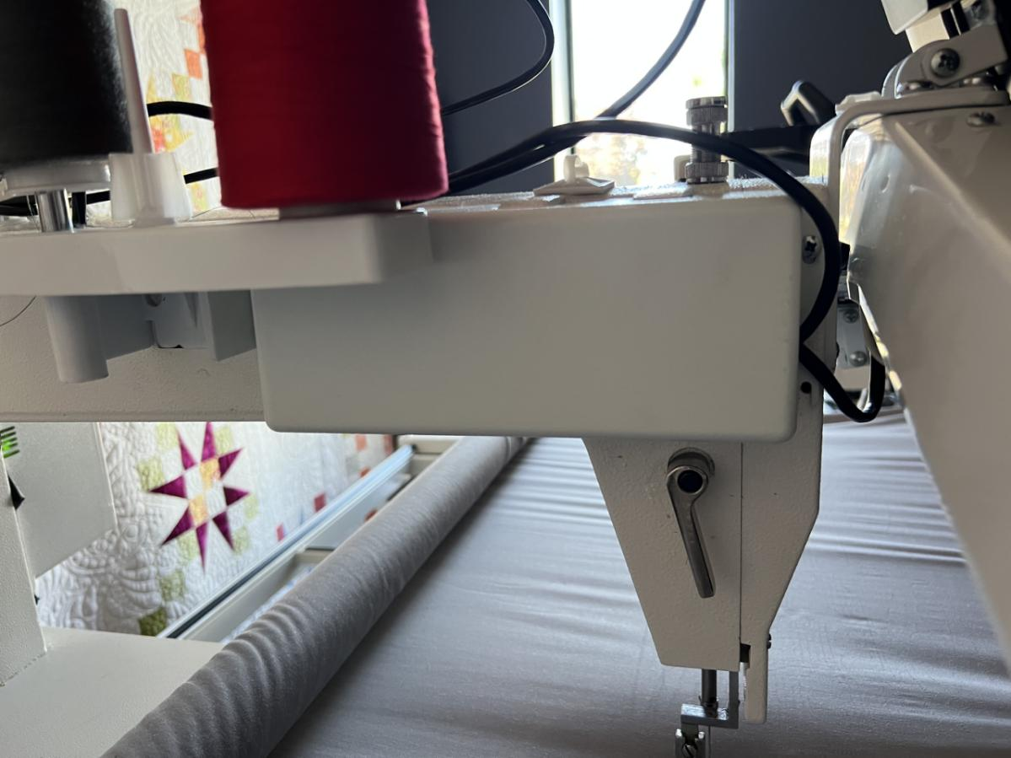

The second way is if your machine does not have a side port under the rocker arm cover.The rocker arm cover is the rectangular cover on the front, left side of the machine (if you are facing the front of the machine) just in front of the thread stand.

We will cover both ways in these instructions.

In this install we are going to have to replace one of the cables that runs thorough your machine.

First you are going to locate the rocker arm cover and unscrew the 4 screws that are holding it on.



You will then see some cables running through an open hole.

**\*If there are zip ties you are going to want to cut those off\***

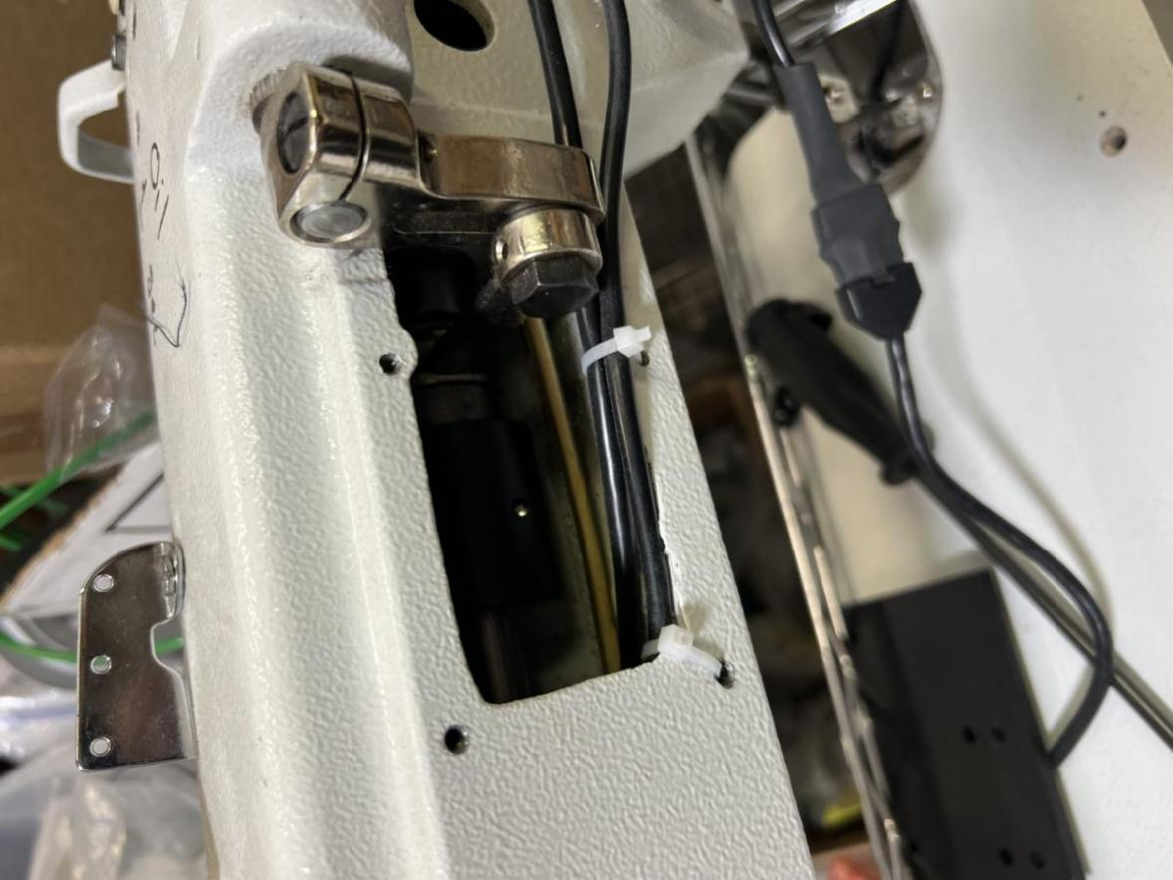

Next locate the a white cover that is located just above your motor. There are 7 screws that need to be unscrews and saved for later. There will also be cables in this part of the machine when you take off the cover.

**\*If there are zip ties you are going to want to cut those off\***

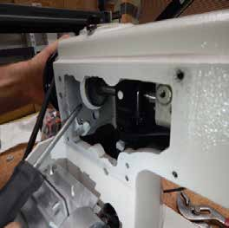 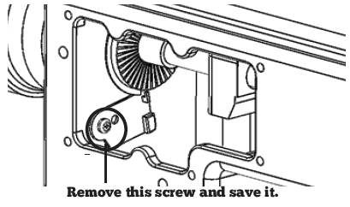

Once that is open we are going to want to locate the white or black box on the rear of your machine. This is the box the power cable plugs into. ***MAKE SURE TO UNPLUG THE POWER CABLE BEFORE YOU DO ANYTHING WITH THIS BOX.*** There are 4 screws that you will need to unscrew and save for later.

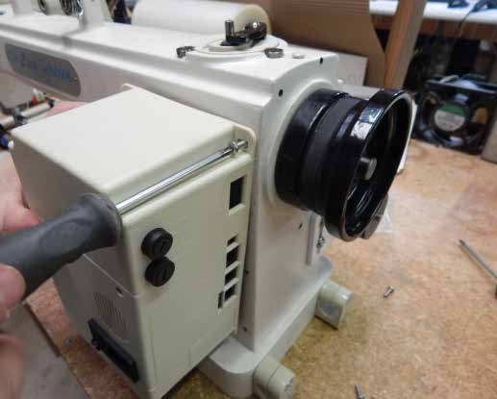

Once the white box is unscrewed there will be many cables plugged into it. Please don’t pull the box back to hard. The inside of the box will look like this or very similar.

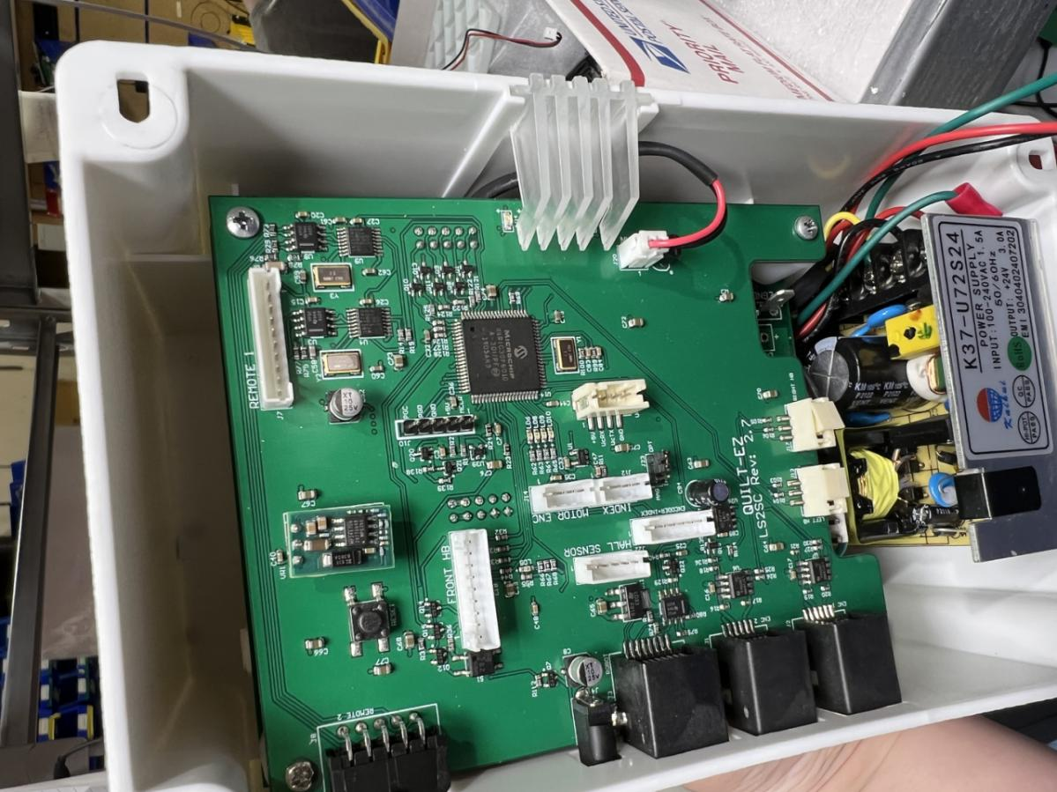

***\* Before touching anything on the board, make sure you are electrically grounded AND/OR that you have touched something metal. This makes it so you won’t shock the board and fry the components.\****

We are now going to find the cable that needs to be replaced.

You are going to go to your display and take that cable and unplug it. Then trace that cable all the way back to the white or black box. It is the cable that is plugged into the port that says Remote 1 on the green board.

In the picture below it is in the yellow rectangle.



***\* Before touching anything on the board, make sure you are electrically grounded AND/OR that you have touched something metal. This makes it so you won’t shock the board and fry the components.\****

Unplug the cable from that port.

Now you are going to want to get the internal remote cable and take the RJ45 end (the end that looks like a phone jack) 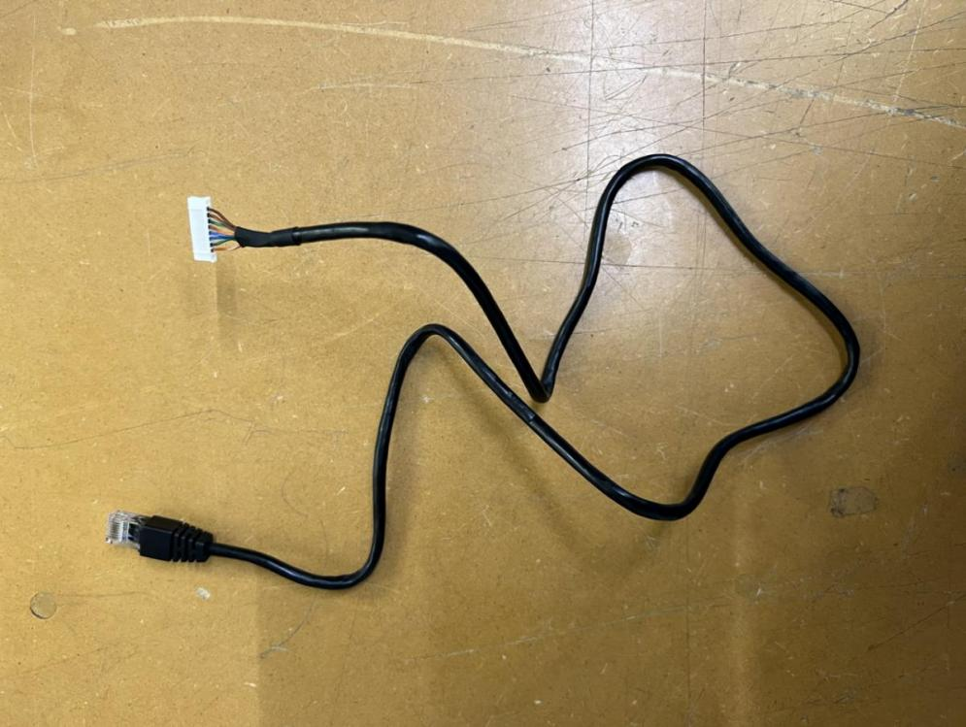

and zip tie or twist tie that end to the white end you unplugged from the green board, as pictured below.

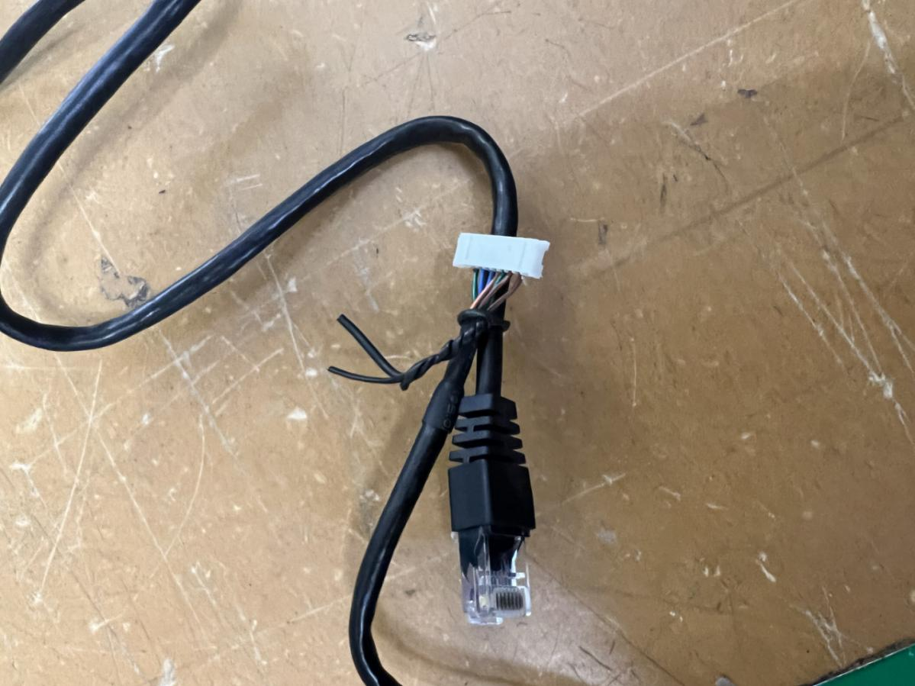

Once you have finished this your are going to go back to the front of the machine and take the cable that you pulled out of the display earlier and then pull the cable through until the new cable with the RJ45 (phone cable end) is pulled through far enough to connect to your display.

Once you have the cable pulled all the way through you are going to want to disconnect the old cable you used to pull the new cable through and screw all the screws back in that you unscrewed.

Next take the RJ45 end (the side that looks like a phone jack) and plug it into the matching port on the translator.

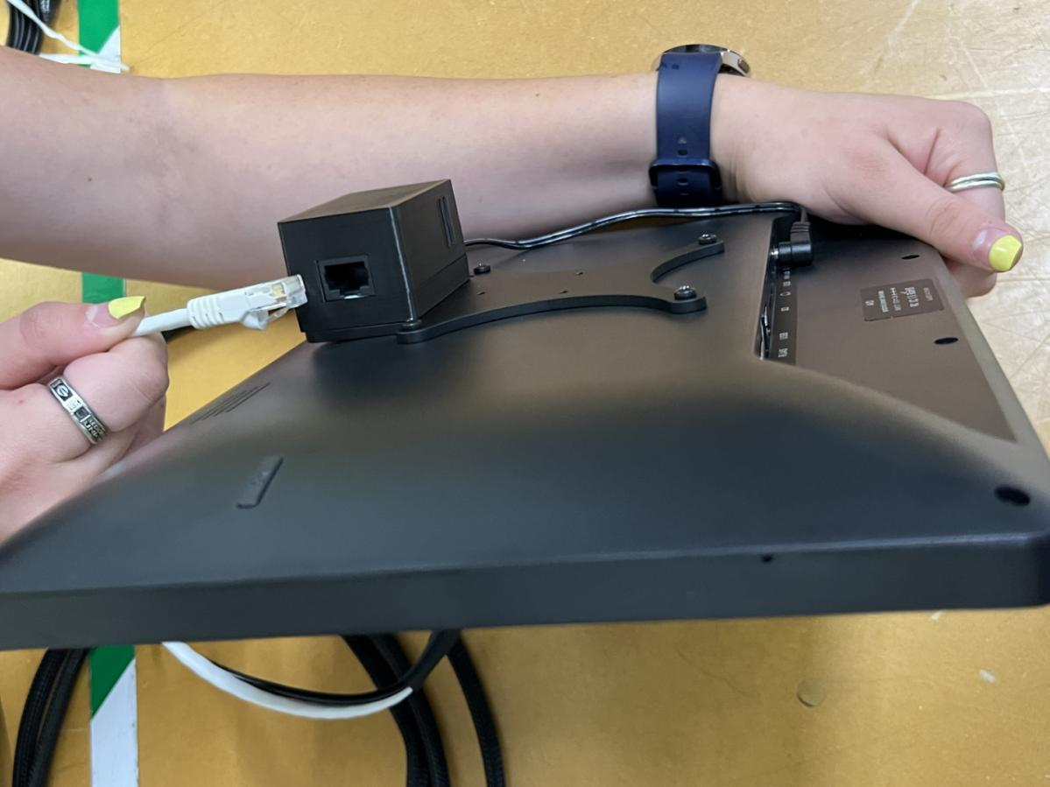

You are all ready to turn on your system! Enjoy!