How to Install your Non-Integrated Display to a USB-B port Butler

**\*Please note that we do not have these parts hooked up to a machine so you can see them better. We recommend you install the Butler and Display bracket to your machine before hooking up all the cables\***

This is what you will require in order to connect your display *(multiple display sizes pictured)*.

Robot

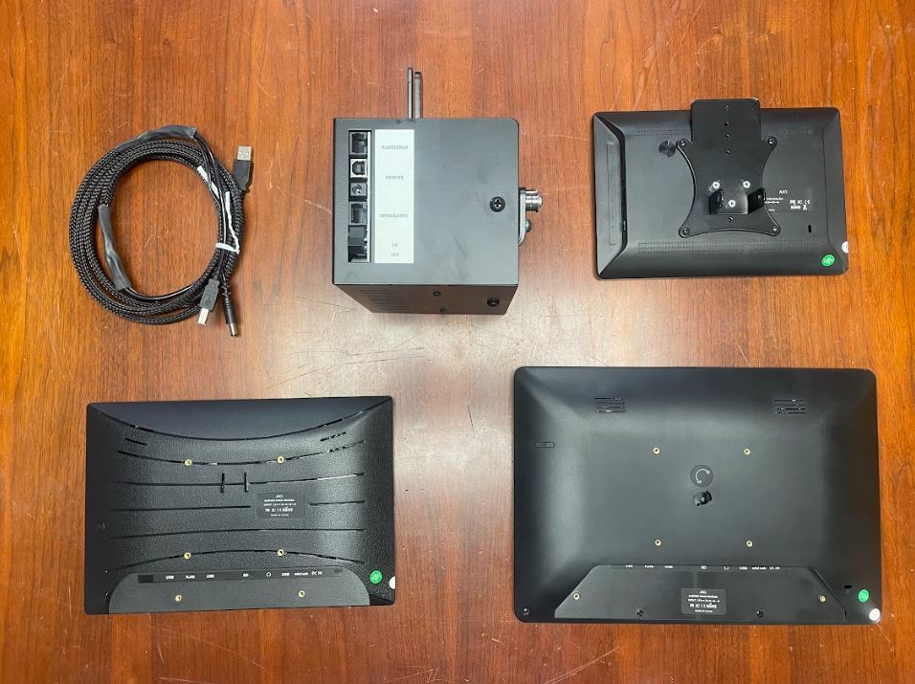

8” EPC

12” EPC

10” EPC

Direct Connect Cable

You are going to want to connect your display bracket on your display to your display bases on your display bracket that is connected to your machine. The picture below shows the display bases in Blue Rectangles.

\***Some display brackets and bases are white, some are black**\*

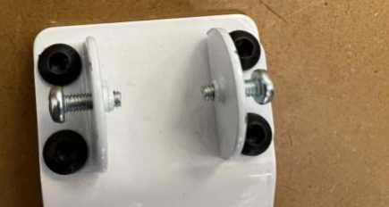

Take out both of the screws

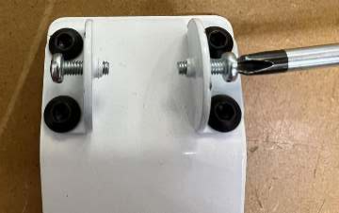

Align the holes in the display clamp with the holes in the display bases. *You may need more than one person for this step*.

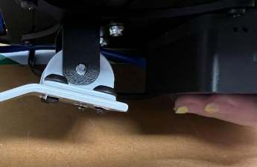

**\*You will want to make sure the screws are tight enough to hold the display. Then adjust the display to the angle you would like and finish tightening the screws.\***

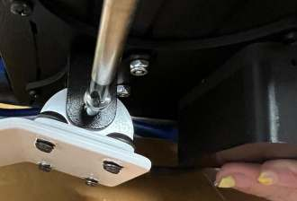

You are now going to connect the Butler and the USB-B and 2.1mm DC (black-tipped) cables.

Take the USB-B cable end and plug it into the USB-B Remote Port.

Take the 2.1mm DC cable end and plug it into the 2.1mm DC port.

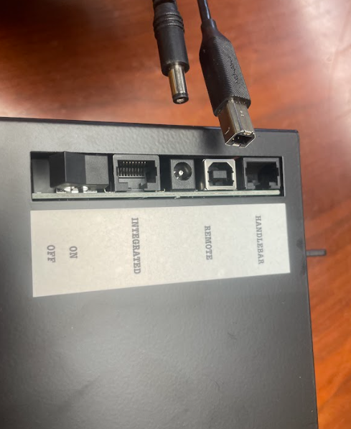

2.1mm DC

Remote Port

USB-B End

When connected, it should look as pictured.

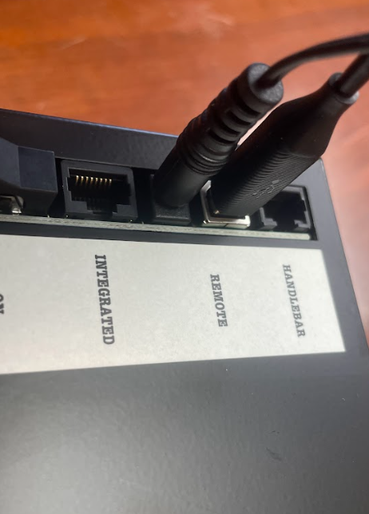

**DO NOT** plug these cables into other ports, or attempt to modify these cable ends.

After these cables are connected, run the cables along the machine to connect to the display at the head of the machine.

You will now connect the USB and 1.7mm DC (yellow-tipped) cables to the Display.

Connecting to 8” Display

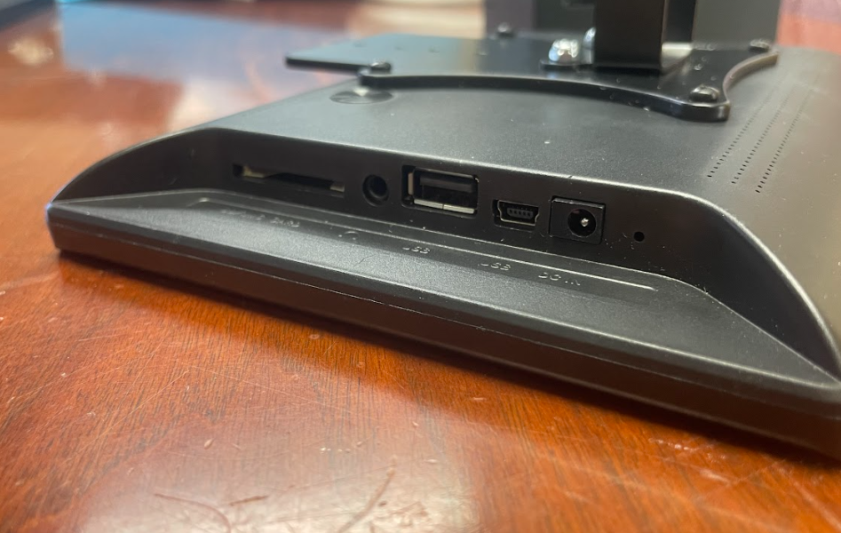

1.7mm DC Port

USB Port

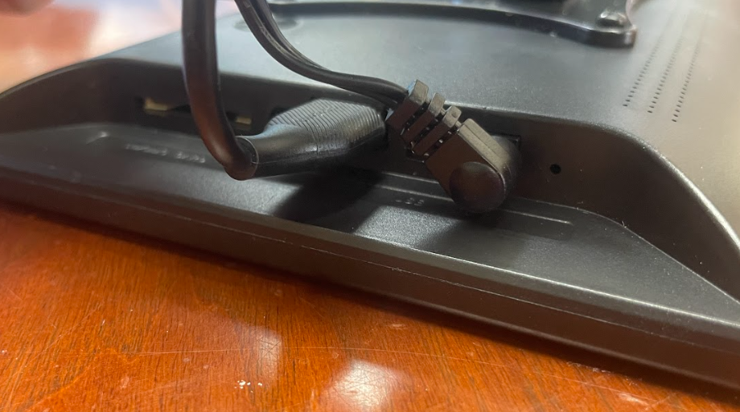

1.7mm DC Port

USB

Connecting to 10” Display

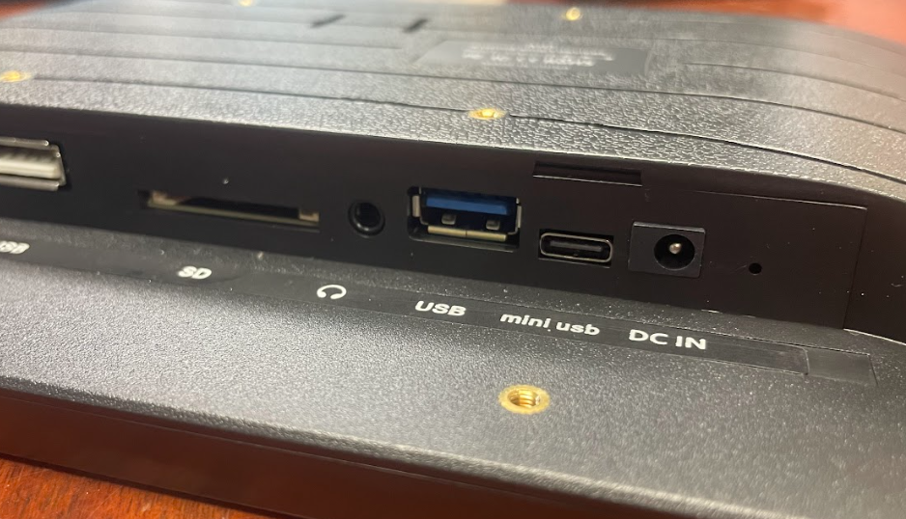

1.7mm DC Port

USB Port

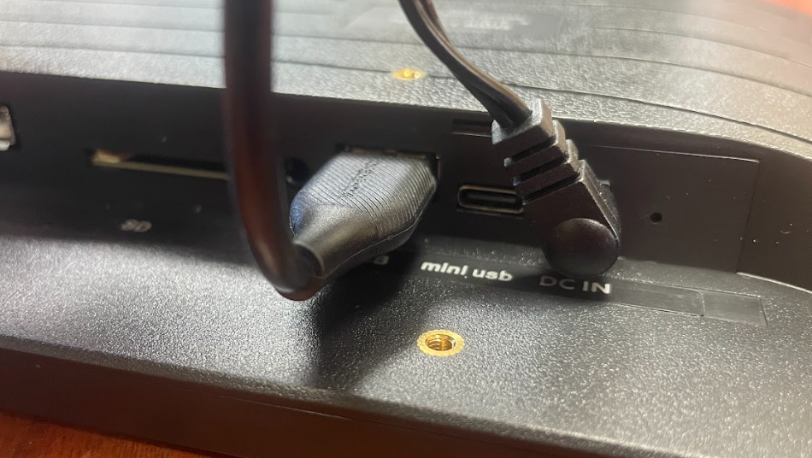

1.7mm DC

USB

Connecting to 12” Display

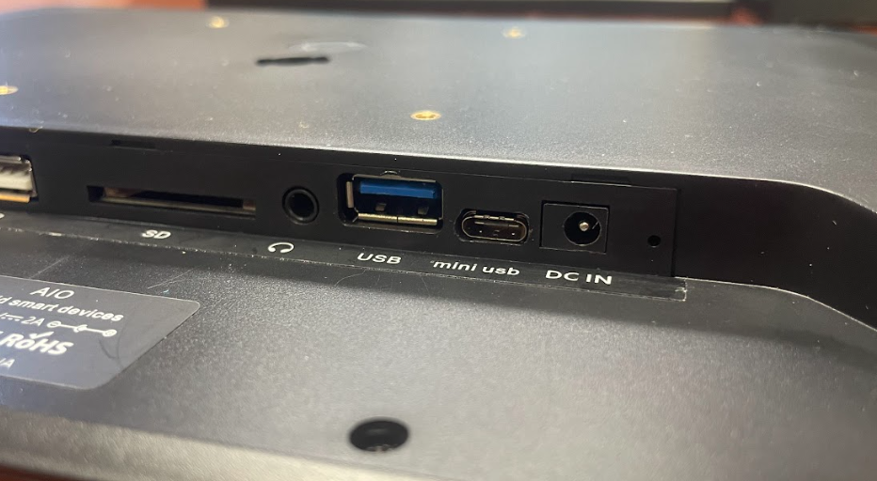

1.7mm DC Port

USB Port

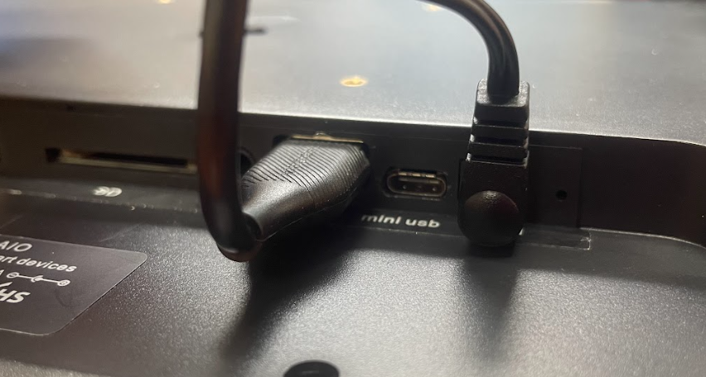

1.7mm DC

USB

You are all ready to turn on your system! Enjoy!